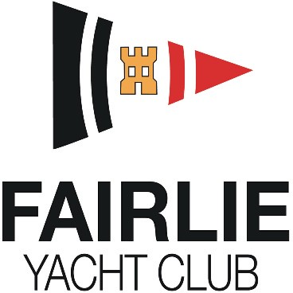

Sponsored by

Autumn Regatta

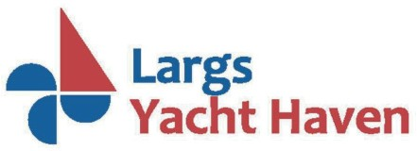Saturday 5th and Sunday 6th Oct 2024

**ENTRY FORM**

Owner………………………………………………………………. Helm’s Name………………………………………………..

Boat Name………………………………………………………... Sail Number………………………………………………….

Type of Boat……………………………………………………… Yacht Club………………….…….………………………….

IRC Rating (Class 1 only) ……………………………………. CYCA Handicap (Classes 2 and 3)………………………



|  |  |  |
| --- | --- | --- |
| I currently berth my boat at Largs Yacht Haven | Y | N |
| I require berthing for the event at Largs Yacht Haven | Y | N |
| A copy of my handicap certificate is attached | Y | N |
| I wish to enter IRC Class | Y |  |
| I wish to enter CYCA Class | Y |  |
| I wish to enter CYCA Restricted Sail Class | Y |  |
| I wish to enter Etchells One Design Class | Y |  |

Address……………………………………………………………………………………………….……………….…….……………………..

Post Code…………………………………………………………….. Home Phone….……………….….….…….……….…………….

Email Address ……………………………………………………… Mobile Phone………………………………….…….….………….

WhatsApp: Add me to the event group chat Yes / No

I agree to be bound by the Racing Rules of Sailing, the appropriate class rules, the Notice of Race and Sailing Instructions that govern this event. I declare that during the event my boat will have valid third-party liability insurance for racing risks, with a minimum cover of £3,000,000 per event or the equivalent.

Signed Skipper/Owner…………………………………………………………………Date………………………………..

**Please email entries to** [**secretary@fairlieyachtclub.org.uk**](mailto:secretary@fairlieyachtclub.org.uk)

**For berthing requirements call Largs Yacht Haven on 01475 675333**